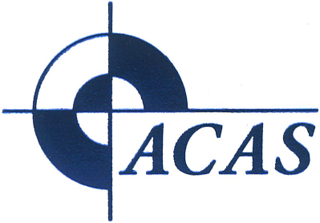
Replacement Certificate Request Form
Australian Centre for Advanced Studies Inc.  PO Box 189, Parkwood, WA 6147 Australia |  |  |  |  |  |  | Email:ross.woods@acas.edu.au
Section 1 – Client Details
Name: |  |  |  |  |  |  |  |  |  |  |  | Date: |  | / /
Address:
Section 2 – Certification Details
I wish to apply for a re-print of a document:
Qualification title/ course name:
Date of course:
Reason for re-print :
Document (Select one) |  |  | Qualification and Transcript of Results Statement of Attainment
Units included (if known):
Unit Code |  |  |  | Unit Code |  |  |  |  |  | Unit Code
Signature: |  |  |  |  |  |  |  |  | Date: |  | / /
Section 3 – Fee and Payment Details
Documents will only be issued if payment is attached/confirmed
Fee for reprint of documents: $AU 30.00 per certificate
Please find enclosed a cheque for $AU30.00 payable to Australian Centre for Advanced Studies Inc
Postal address: PO Box 189, Riverton WA 6147, Australia
Direct Transfer - BSB: 036-069 | Acct No: 235-064 | Acct Name: Australian Centre for Advanced Studies Inc
Admin Use Only
All fees paid : |  | Yes |  |  | No | Signature: |  |  |  |  |  |  | Date: |  | / /
Certificate sent: |  | Yes |  |  | No | Signature: |  |  |  |  |  |  | Date: |  | / /
Certificate copy filed: |  | Yes |  |  | No | Signature: |  |  |  |  |  |  | Date: |  | / /

